Assignment 12.
- What is Structure in DDIC & it's types.
- A Structure is a collection of fields grouped together, but it does not store data in the database.
Or
- Structure is collection of fields of same data type or different data type
- Two types in Structure
- Include Structure
- Append Structure

- Include Structure:
- An Include Structure is used to reuse fields of one table inside another table.
- Instead of creating the same fields again and again, we include an existing structure.

- It is a reusable structure.
- We can insert the include structure at any point.
- It is applicable to customer specific tables(name starting with Z,Y). It is not applicable to SAP specific(standard) tables.

- Example:
- If you create a structure with:
- Created Date
- Created Time
- Created By
You can include this structure in many tables using Include.

- Append Structure
- An Append Structure is used to add extra fields to a standard SAP table or structure without modifying the original object.

- It is not a reusable structure.
- It always inserts at the last.
- It is applicable to both customer specific tables (name starting with Z,Y) and SAP tables.

- Difference between append & include structure.
Inlcude | Append
Used to reuse fields of one table inside another table or structure | Used to add new fields to an existing table or structure
Can be inserted at any position within a table or structure. | Must be appended at the very end of the fields list.
Can be used in custom tables and structures | Mostly used to enhance standard SAP tables
Highly reusable; the same structure can be included in multiple tables or structures. | Tied to a single table or structure; a specific append structure name can only be used once.
Changes to the included structure affect all the tables/structures where it is used. | Changes only affect the single, specific table/structure to which it is appended.
Used for common reusable fields | Used for custom enhancements in real projects

- Can we create structure inside structure? If yes in how many ways we can create the same?
- Yes We can put a structure inside another structure.
- Example:
- Create Structure A
- Create Structure B
- Open Structure A
- Choose Include Structure
- Enter Structure B name
- We can create a structure inside another structure in two ways: using include structure and by defining a structure as a field type.

- Try to include same include structure twice in same table & check what will happen? If any error occours then how to overcome on it.
- It will give an error.
- Like Field name already exists.
- The include structure contains fields.
- Including it twice means the same field names will appear twice in the table.
- Database tables cannot have duplicate field names.
- So activation fails with a duplicate field error.
- It can be resolved by creating another structure with different field names.

- How many include structure can be include in single table?
- We can include multiple include structures in a single table.
- We cannot include the same include structure twice in the same table

- Create Append structure & create one more append structure then see where it will appear?
- It will appear At the bottom of the table
- Below the first append structure
- All append structures are displayed after the main table fields.
- ->If multiple append structures are created for a table, they appear at the end of the table below the original fields.

- what is enhancement category?
- Enhancement category controls how a table/structure can be enhanced.
- 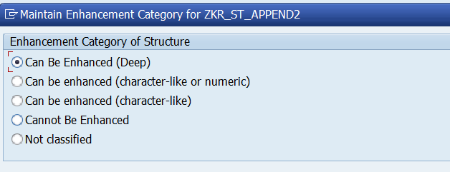
- Can Be Enhanced (Deep):
- Allows all types of fields
- Used when structure may contain complex/deep types

- Can be enhanced (character-like or numeric):
- we can enhance the tables/structure with fields that are strictly character or numeric types.
- Can be Enhanced (Character Type):
- can be enhanced by only including character type fields
- No numeric types:
- Cannot Be Enhanced
- Append not allowed at all.
- Not classified:
- No category defined

- Enhancement category defines whether and how a table or structure can be enhanced using append structures.

